**RED HAT OPENSHIFT DEPLOYMENT OF SAMPLE PROJECT FROM GIT**

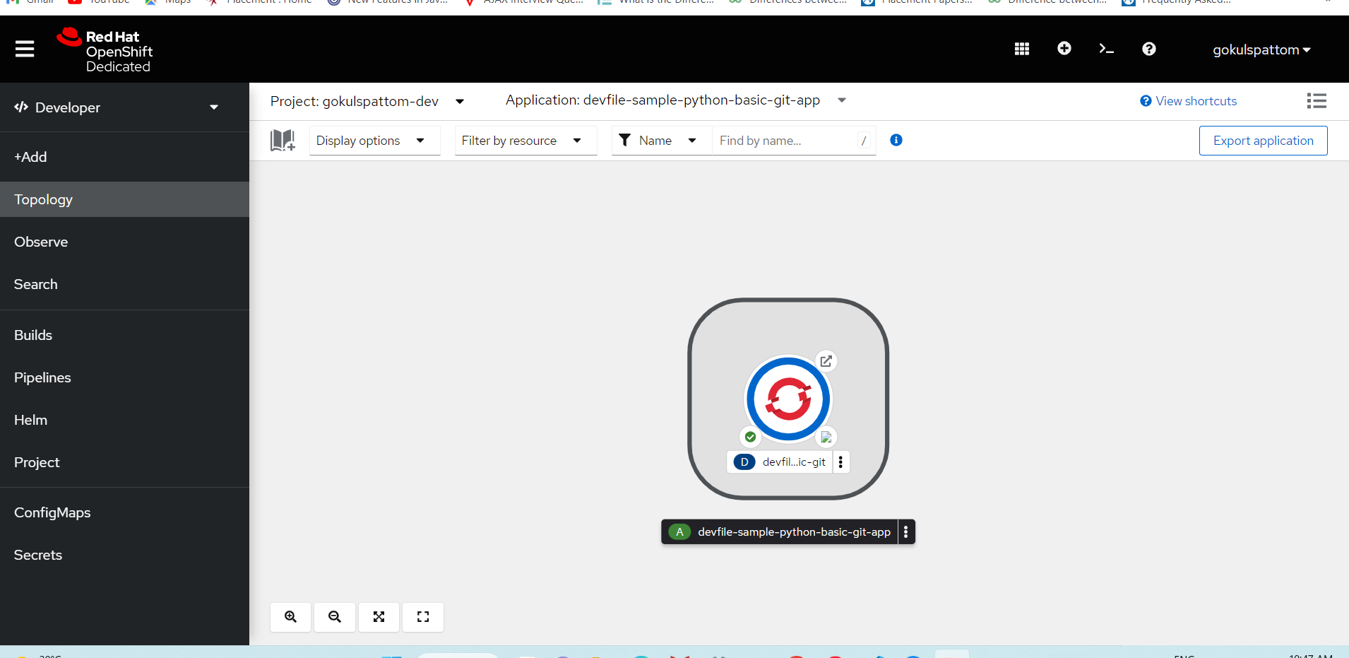

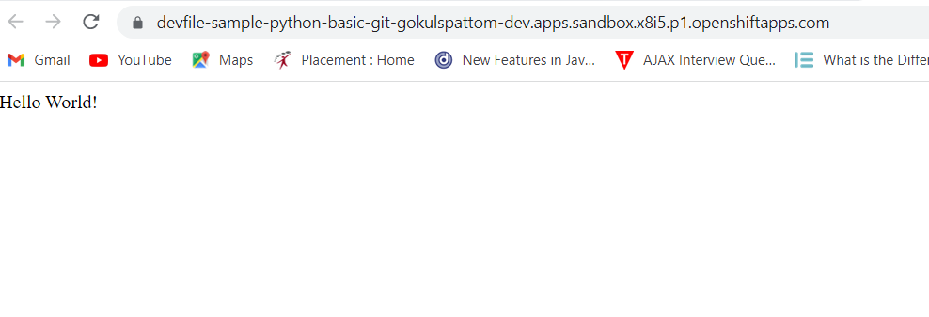

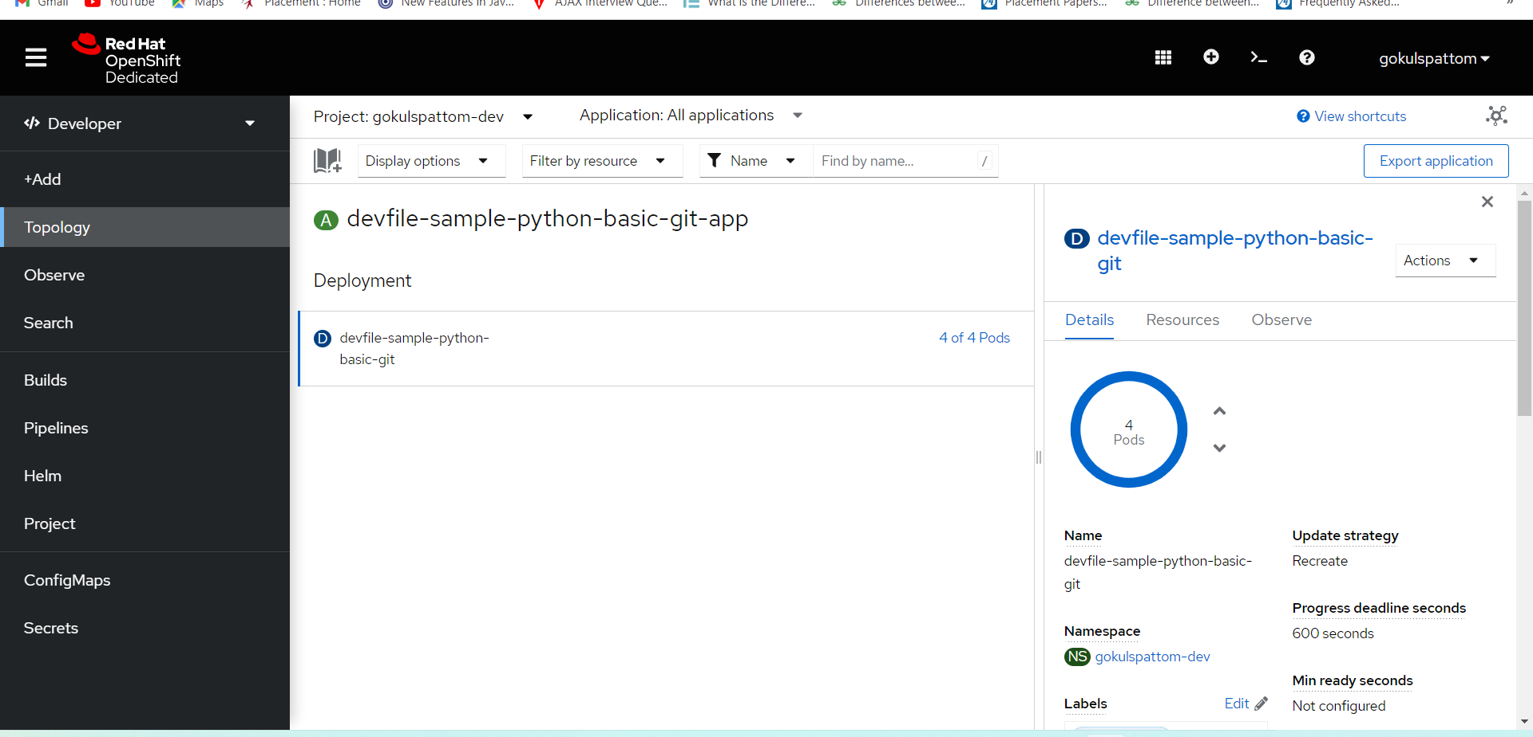

**DEPLOYMENT OF IMAGE FROM MY REPO IN DOCKER HUB**

